ChemPreview is to utilize augmented reality MetaGlass to build, visualize, modify and adjust molecular structures.

**ChemPreview Guide**

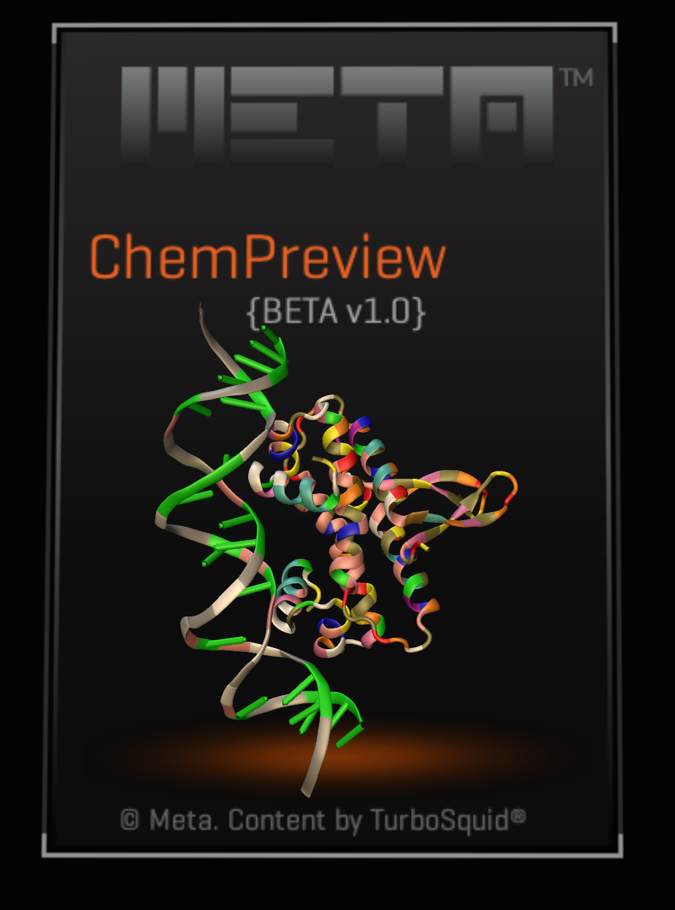

(The PDB code of the cover structure is 5E3M )

**MetaModels Menu**

The menu panel is right in front of users, and has four sub-menus. The first one is *MetaModels*, which contains meta models for single bond and chemical elements 1-36. Clicking the thumbnail will generate a new atom or a new single bond. A convenient way to build a chemical system is to load a file (it is introduced *File* menu part).

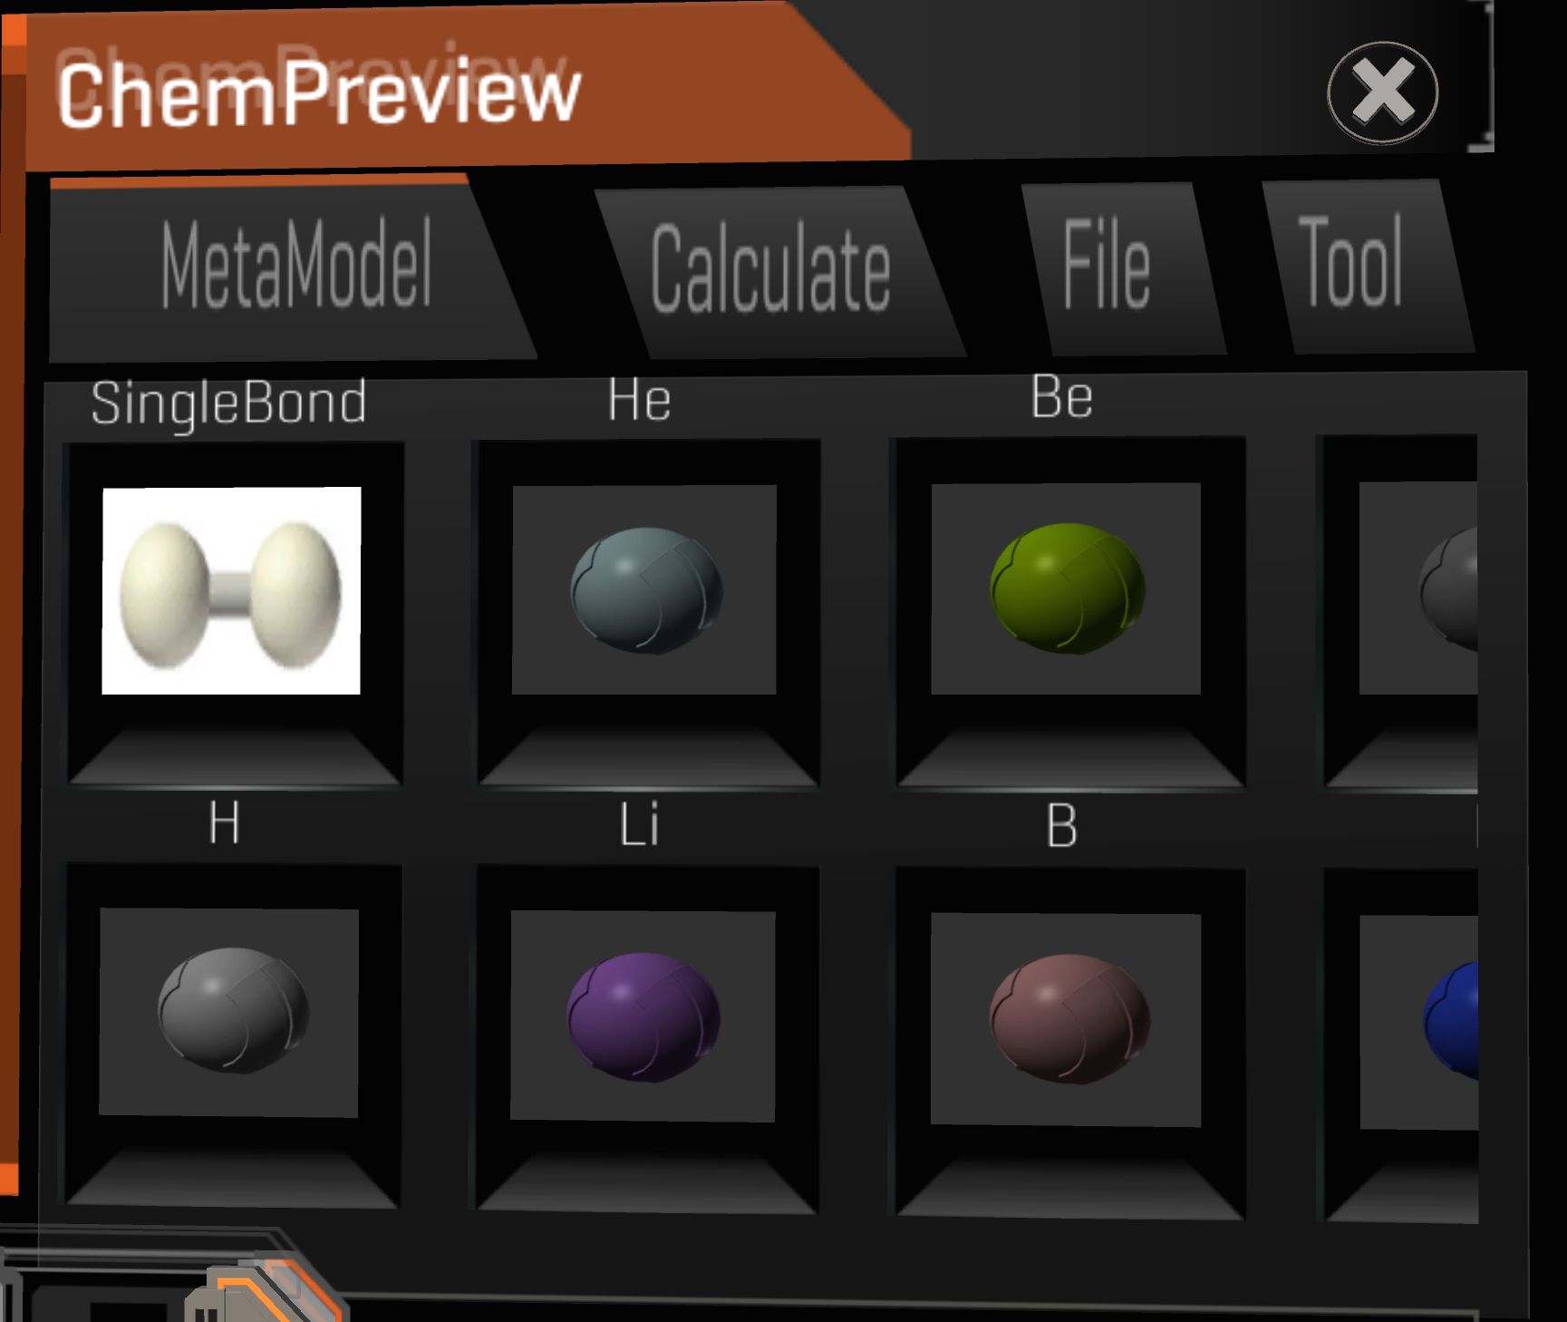

**Calculate Menu**

The calculation function is the main goal of ChemPreview. So ChemPreview can provide a 3D visualization of molecule structure and reliable chemistry and physics information of the molecule at the same time.

Click *Cancel* button to the upper menu *MetaModels*.

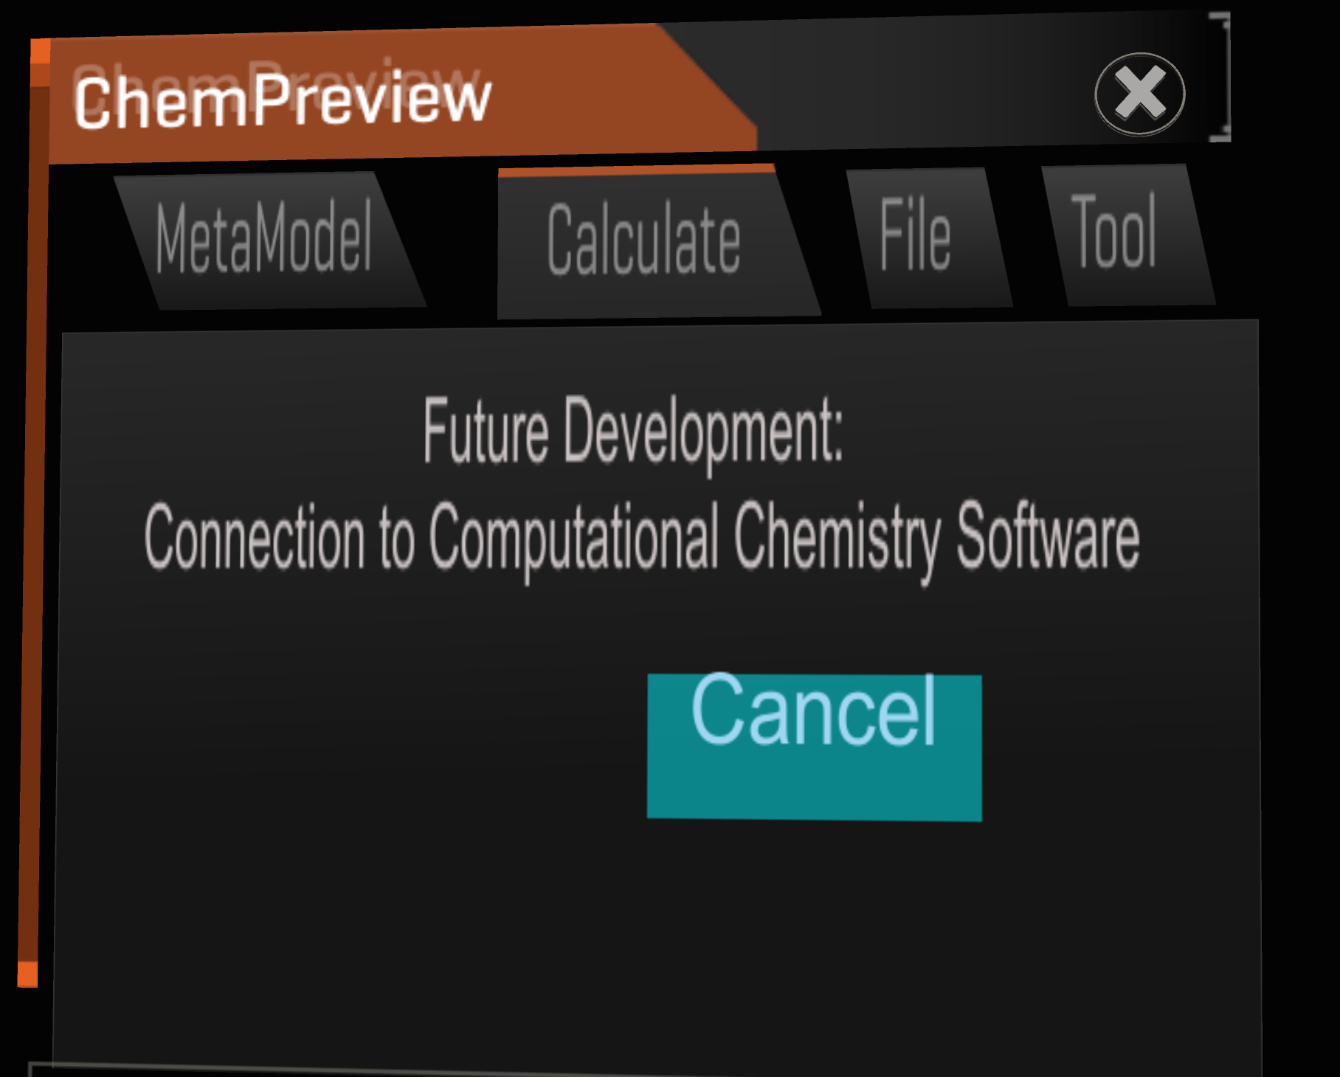

**File Menu**

The *File* menu mainly is to load a molecule structure from a file and save a molecule structure into a file.

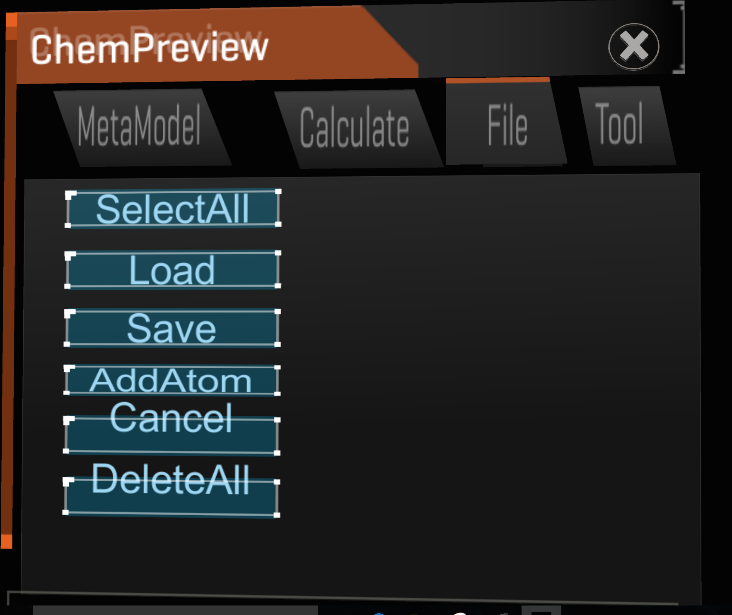

Select the whole system to resize, move and rotate the overall molecular structure.

Go back to the menu *MetaModels*

1). *Load* : build a molecule from a PDBML/XML file

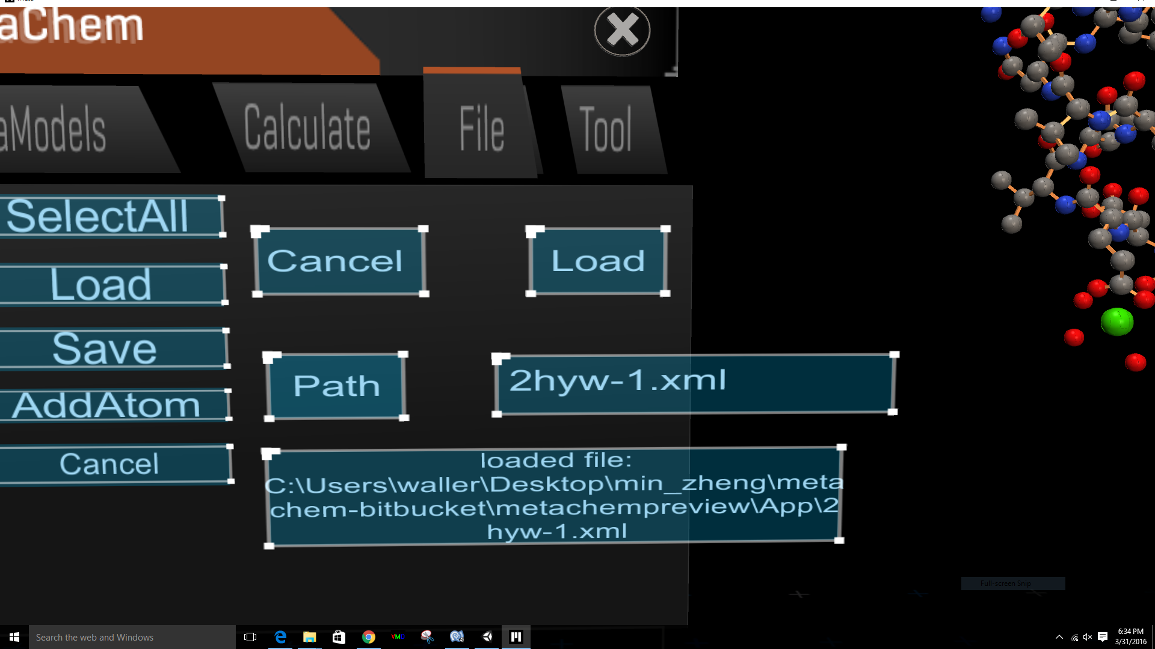

2) *AddAtom* : add a specific atom into the current molecular structure.

type the information of the new atom

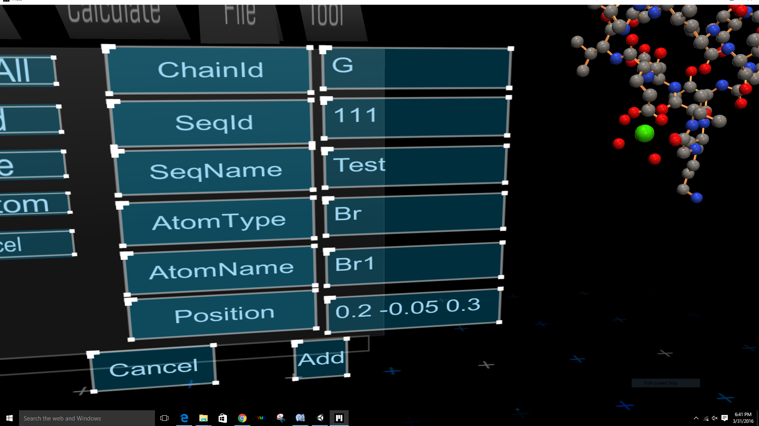

then click *Add* buttion, we can see the new added Br atom in the following figure.

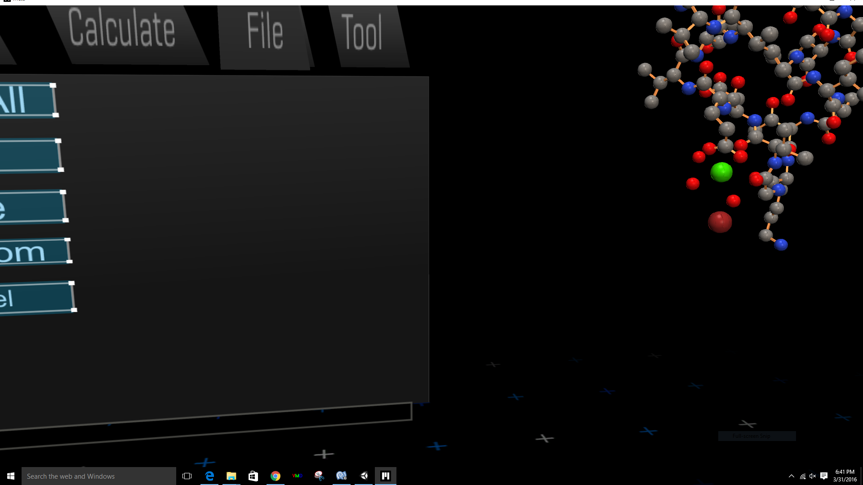

The new atom

3) *Save* : store the current structure into a PDBML/XML file.

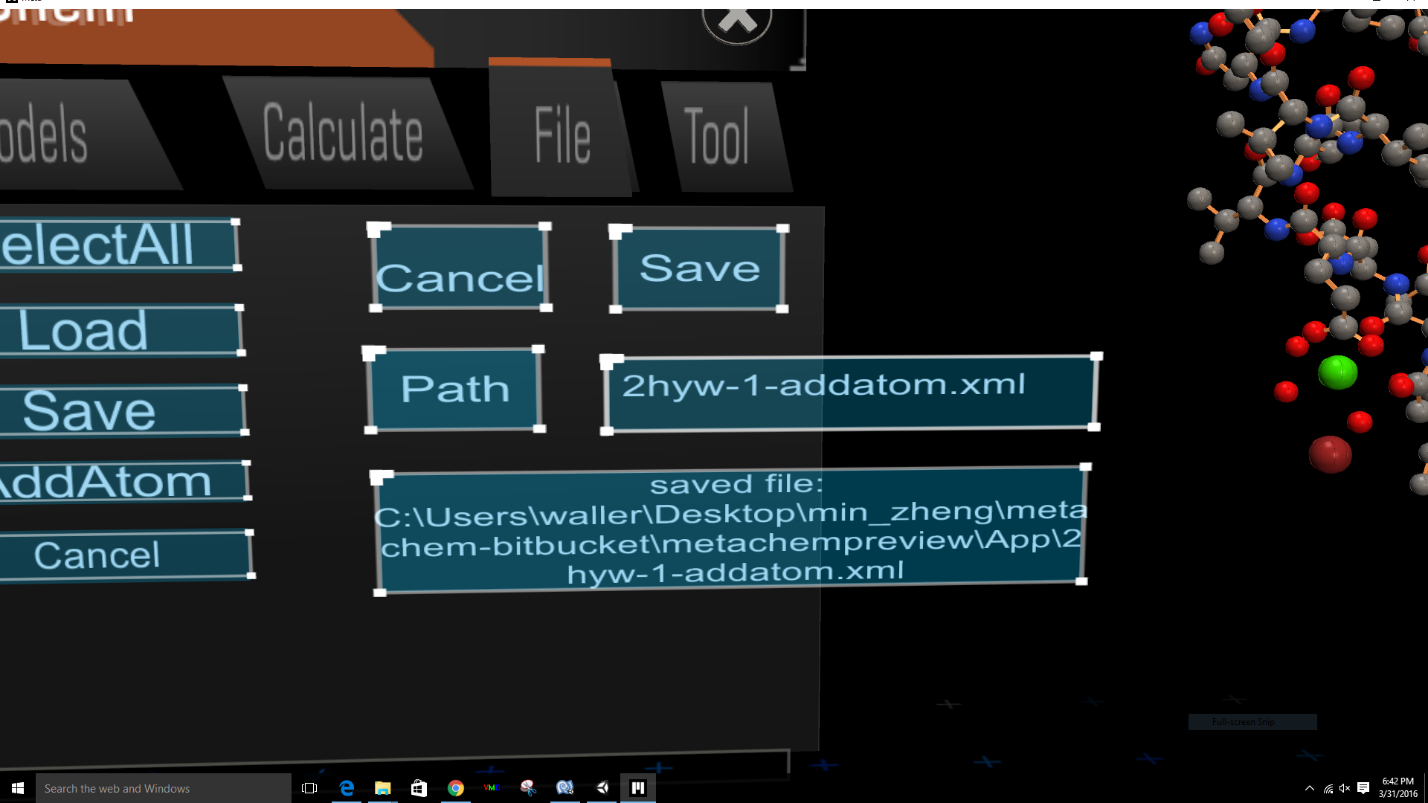

open the saved file 2hyw-1-addatom.xml, at the end of the file there is information for the newly added atom Br.

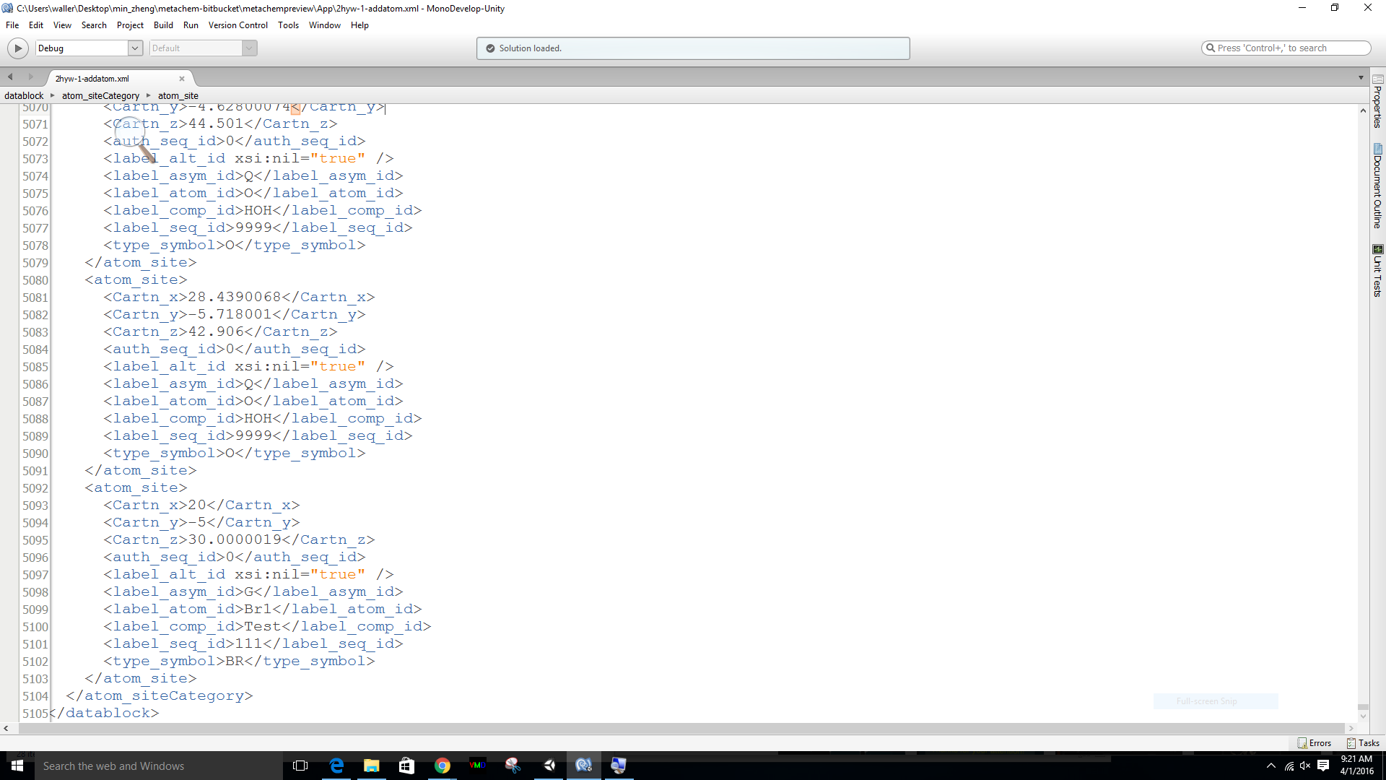

The newly added Br atom

**Tool Menu**

The *Tool* mainly is to measure the distance, angle and dihedral.

1) *Group:* select several objects (atoms) at the same time and operate them as one object.

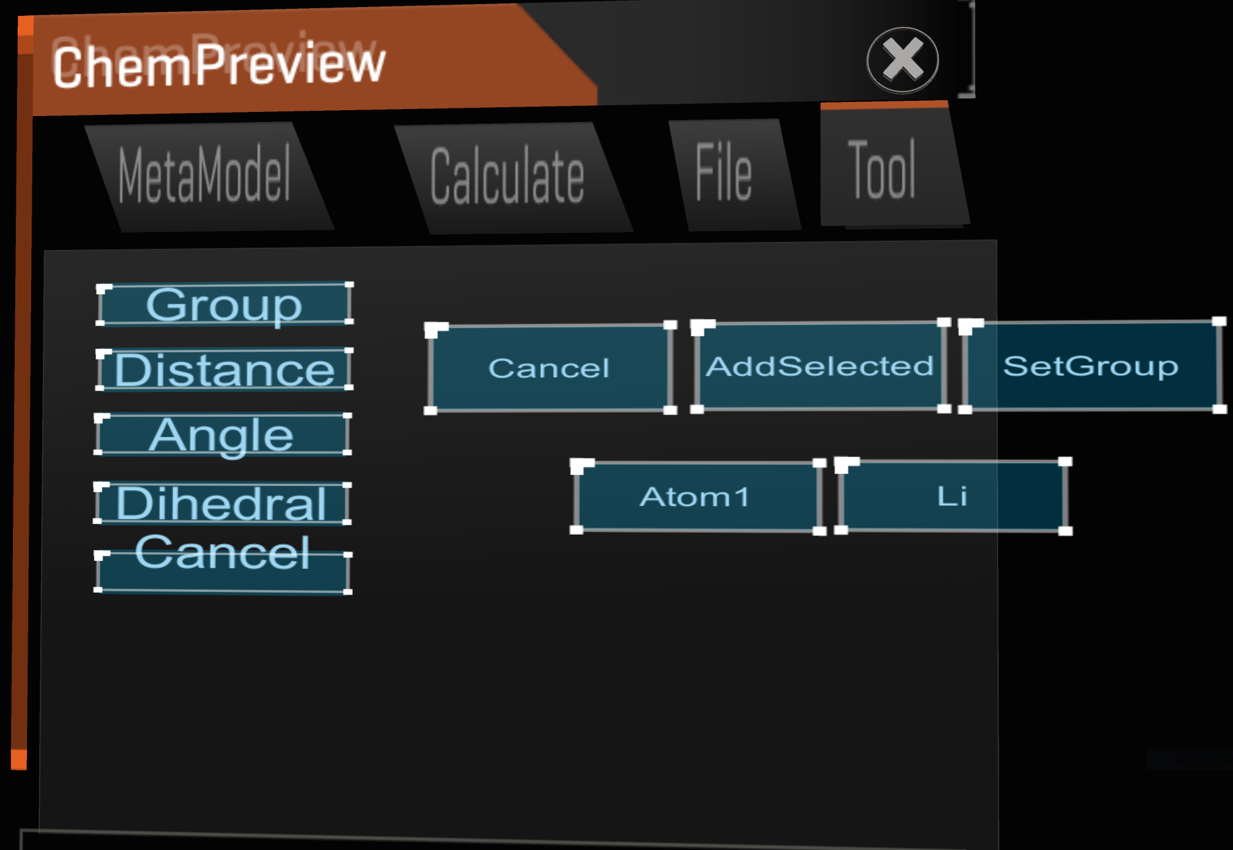

2) *Distance:* get the distance of two atoms

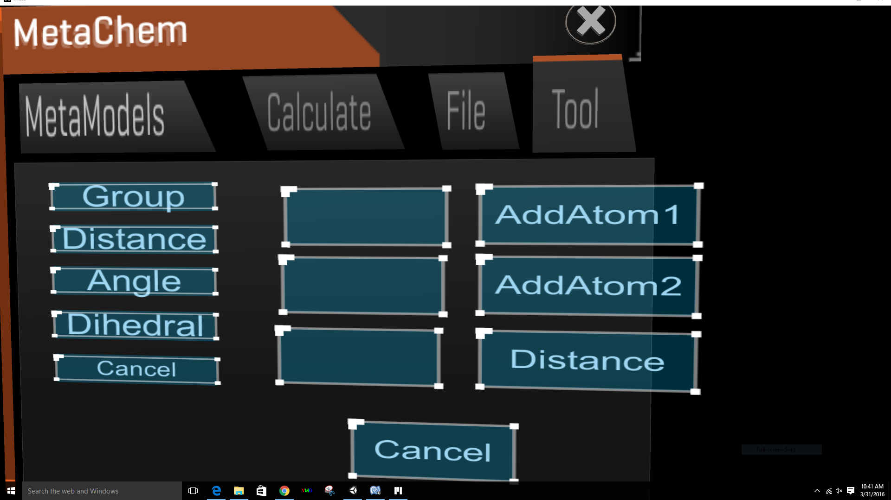

3) *Angle*: get the angle of three atoms

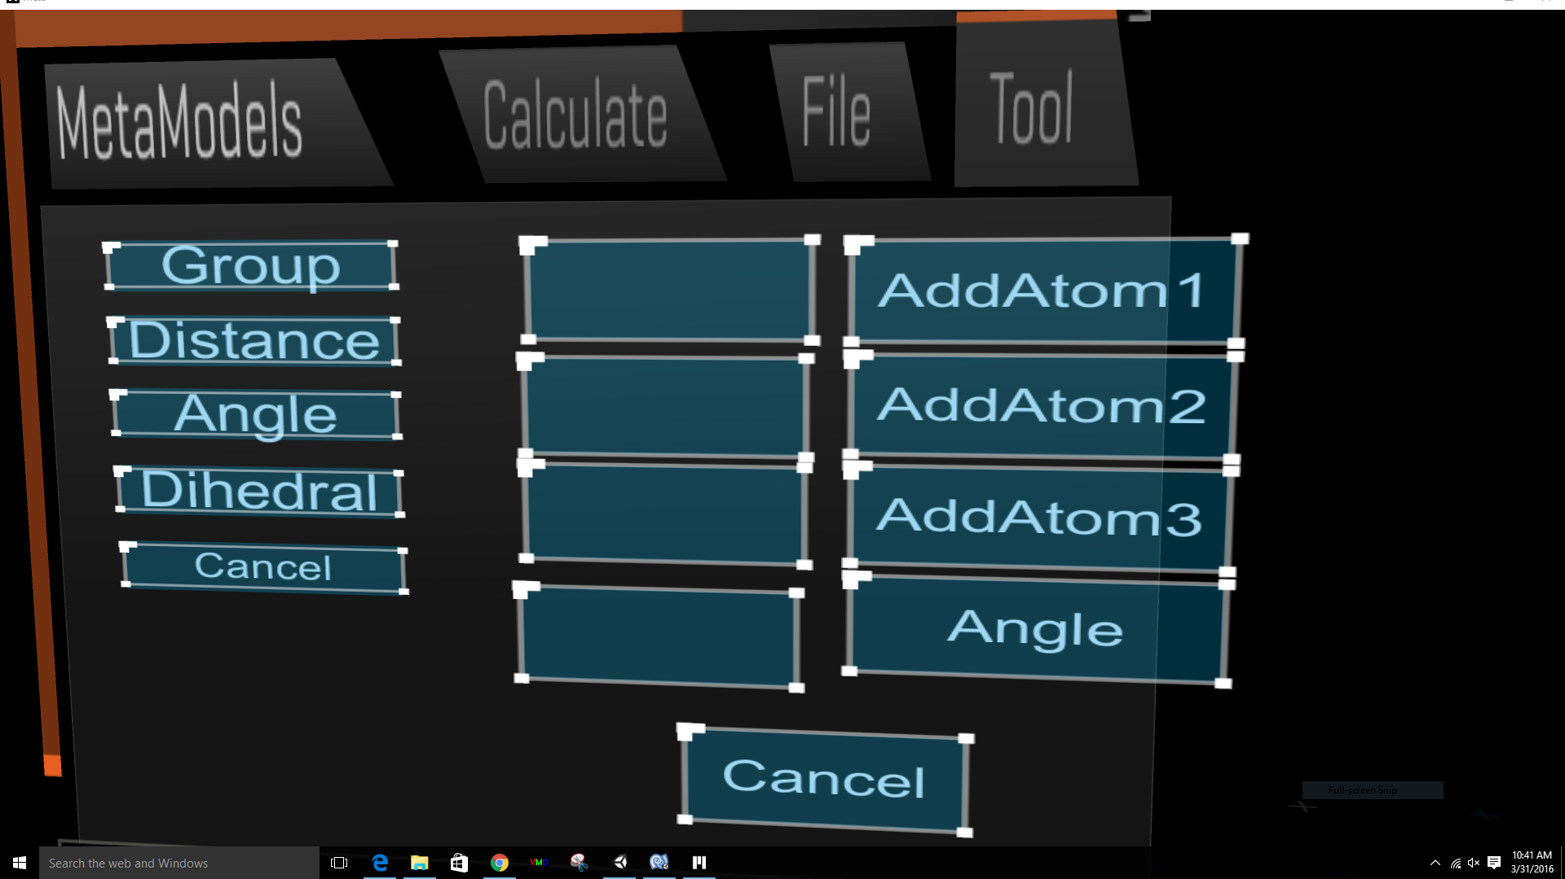

4) *Dihedral*: get the dihedral of four atoms

